Lengow Cartridge

###### Version 22.1.0



Contents

Summary 3

Component Overview 4

Functional Overview 4

Limitations & Constraints 4

Compatibility 4

Privacy 4

Implementation Guide 5

Setting Workspace 5

Import Meta Data 5

Adding Permissions for Showing extension Cartridge 6

Add an API Client 6

Update Cartridge Path 6

Update OCAPI Settings 7

Configure Site Preferences 7

Update Job Configuration 7

Operations 9

Failover/Recovery Process 9

Supported Locales 9

Roles & Responsibilities 9

Support 9

Testing 9

Integration Testing 9

Known Issues 10

Release History 10

# Summary

**Lengow is a central platform at the heart of your e-commerce strategy. Select and import your product data from SFCC to Lengow and optimize it for hundreds of different marketing channels.**

**The current version includes support for integration of Product JOB feeds where there is a dedicated Business Manager extension to select what attributes to export and for which locales out of active locales for the site selected. Merchants can configure the jobs to skip Master Products, sending only available products or sending only online products.**

**Merchant teams are required also to configure the cartridge with the valid SFTP credentials and site configurations in Commerce Cloud Business Manager to enable upload of generated files to Lengow SFTP servers. Please make sure you have secured SFTP credentials to expose your feeds to Lengow before you start. If you don't, Lengow can provide you SFTP credentials at extra cost depending on the volumetry of your data."**

**This document describes how to integrate the cartridges with your business manager, and assumes you have knowledge about the SFCC Business Manager. The integration package consists of following contents:**

* **Cartridges called “bm_lengow” and “int_lengow” to be updated to active code version.**
* **A site-template (inside metadata) containing new attributes, jobs and services.**
* **This document which is compatible for both Storefront Reference Architecture and Site Genesis.**
* **The integration test cases to test functional use cases.**

**The cartridges include support Controllers, SFRA and Pipelines.**

# Component Overview

## Functional Overview

Key Features:

* LengowCatalogFeed Job Step pushes product data for the site selected to IMPEX and then LengowUploadFeed pushes the data from IMPEX location to SFTP servers.
* Flexibility for merchants to set the configuration of job to skip Master Products, sending only available products or sending only online products.
* Flexibility to push all the site products or pushing only for one catalog of the site in scope.
* Job provides the functionality to push the data for all the selected locales from the Business manager extension page. One file per locale will be created.
* Business Manager Page also gives the functionality to select what product attributes to push to feed.
* Feed files are pushed to Lengow

## Limitations & Constraints

There are not any limitations and constraints for these cartridges. There is not any risk of optimistic locking failure because there is not any transaction associated with any JOB run.

## Compatibility

This cartridge is compatible with all the three frameworks of SFCC i.e. pipelines version 105.2.0, controllers version 105.2.0 and SFRA version 6.0.0. Cartridge has been tested against code compatibility version 21.7.

## Privacy

By installing the Lengow cartridge you agree to let Lengow process and read your data feeds.

# 

# Implementation Guide

## Setting Workspace

This repository contains 2 cartridges that are required for full functionality. Functionalities of both cartridges are as follows:

* int_lengow – Implements the job components for creating csv feed and uploading to SFTP servers.
* bm_lengow – Implements the BM extension cartridge to select export attributes and locales.

Steps to setup workspace are as follows:

* Clone this repository. The name of the top-level folder is link_lengow.
* Navigate to link_lengow folder where package.json is present.
* In the link_lengow folder, run the following commands:
  + npm install – This will download all the dependencies required.
  + npm run build – This will compile js and css files
  + npm run lint – To check any linting errors.
* Upload both the compiled cartridges to active code version on Business Manager.

## Update Cartridge Path

Update BM cartridge path. To do this, follow below steps-

* Go to Administration > Sites > Manage Sites.
* Click on **Business Manger** Site.
* Add “:bm_lengow:int_lengow” to the cartridge path.

Update Site cartridge path. To do this, follow below steps-

* Go to Administration > Sites > Manage Sites.
* Click on your site from the opened site list and then go to Settings tab.
* Add “:int_lengow” to the cartridge path.

## Import Meta Data

Update and Import following site configuration meta-data through Business Manager.

* Open file link_lengow/metadata/site-template/jobs.xml and search for below keywords and replace with actual data-
  + RefArch– Replace with your current site id
  + UpdateSftpFolderNameHere – Replace with SFTP relative folder path. eg - /home/lengow/
* Open file link_lengow/metadata/site-template/services.xml and search for below keywords and replace with actual data-
  + UpdateSftpHostHere – Replace with SFTP host name
  + UpdateSftpUserNameHere – Replace with SFTP Username
  + UpdateSftpPasswordHere – Replace with SFTP Password
* Go to link_lengow/metadata/site-template.
* Zip site-template folder.
* Go to Administration->Site Development->Site Import & Export and upload site-template.zip file.
* Import the uploaded zip file.

## Adding permissions for showing BM Extension Cartridge

Add the permissions to the site to show the Lengow Business Manager module. Steps are below-

* Go to Administration > Organization > Roles & Permissions > Administrator - Business Manager Modules.
* Select your site.
* Give the write permissions to Lengow module and click Update.



## 

## Add an API Client

Account administrators can use Account Manager to create API clients. The Open Commerce API must be accessed using an API client. The API client ID must be appended to the URLs used to interact with the Open Commerce API. An API Client ID that is meant for OCAPI must *not* have the role "Salesforce Commerce API" assigned to it.

To add an API client:

* Log into Account Manager.
* Click API Client.
* The API Clients page opens, showing a list of API clients. For each client, the page shows the API client ID, the display name, and the status.
* Click Add API Client.
* The Add API Client page opens.
* In the Display Name field, enter the display name of the client.
* In the Password field, enter the password.
* In the Confirm Password field, reenter the password.

The Access Control section indicates the status of the API client.

* In the Organizations section, click Add.

The Assign Organizations page opens.

* In the Assign Organizations page, do the following:
  + Search for organizations.
  + To add the API client to an organization, select the organization’s checkbox (each API client must belong to one or more organizations).
  + Click Add.
* Click Save - Account Manager creates the API client

Note – If you already have client Id and password, you can use the same for this integration.

## Update OCAPI Settings

Update the OCAPI settings to give permission to client id for accessing system object resources

* Go to Administration > Site Development > Open Commerce API Settings.
* Select “Data” from the Type dropdown.
* Append the following snippet after putting the client id generated before.

{

"_v": "18.1",

"clients": [

{

"client_id": "Enter Client Id here",

"resources": [

{

"resource_id": "/system_object_definitions/*/attribute_definitions",

"methods": [

"get"

],

"read_attributes": "(**)",

"write_attributes": "(**)"

}

]

}

]

}

* Click Save.

## Configure Site Preferences

Update Lengow site preference through Business Manager > Storefront Site > Site Preferences > Custom Preferences. Select Group – “LengowPreferences”

|  |  |
| --- | --- |
| **Site Preference ID** | **Value** |
| ocapiClientId | Add the client id created in “Add an API Client” step |
| ocapiClientPassword | Add the client password created in “Add an API Client” step |

## Update Job Configuration

All scheduled jobs provided as part of the cartridge must be configured as required. As implementer requirements will vary, this configuration has been omitted from the cartridge meta-data. Specifically, the following must be configured for each Job:

* Schedule - Job schedule and recurring settings to be set.
* Notification Settings - Email notification to be provided in the event of job failure/success. This should be set to a current and active email address which is monitored so that issues can be identified and resolved.
* Job Steps – Verify the job steps are intact. There are two steps: Generate feed and Upload Feed.
  + **LengowCatalogFeed** – This component has eight job parameters:
    - ImpexFolderName – Impex folder name where the files will be created.
    - FileNamePrefix – This param is used to specify the file name prefix.
    - IncludeTimeStamp – This param is to specify if time stamp needs to be appended to file name.
    - CatalogID – This param will specify the catalog to be exported. If empty, step will export all site products.
    - SkipMaster – This param will skip the master products.
    - AvailableOnly – This param will export only the available products
    - OnlineOnly – This param will export only the online products.
    - IsDisabled – This param will skip the step.
  + **LengowUploadFeed** – This component has eight job parameters:
    - ServiceID – SFTP Service id configured in service framework
    - SftpFolderName– SFTP folder path where the files will be uploaded.
    - ImpexFolderName– Impex folder name from where the files will be picked up.
    - IsDisabled – This param will skip the step.

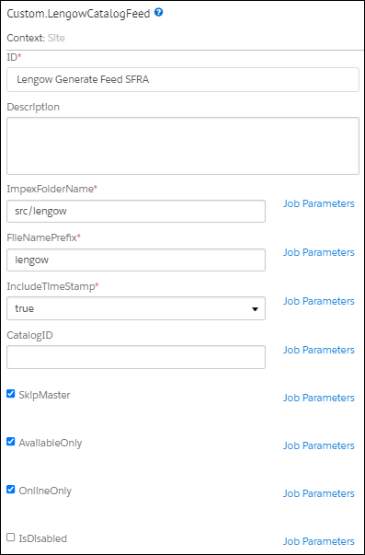 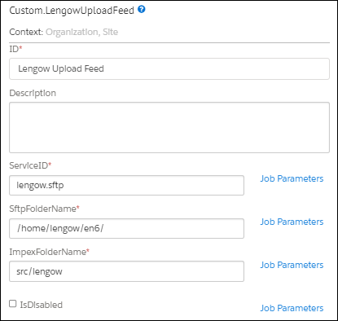

# Operations

## Failover/Recovery Process

Lengow workflows are meant to upload the files to SFTP servers. Lengow servers will retrieve your new data from your SFTP server every time a new repository is made at your end.

## Supported Locales

This cartridge supports all the available locales. Locales can be selected from Business Manager Extension Cartridge Page.

## Roles & Responsibilities

There are no recurring tasks required by the merchant. Once configurations are set up, the functionality runs on demand/as scheduled. The email address defined in the **JOB’s Notification** setting should be monitored proactively to address any issues with the jobs.

## Support

In case of technical issue, customers can raise a ticket by writing to the Lengow technical support team from this URL: <https://help.lengow.com/hc/fr/requests/new>

## Testing

In order to test this cartridge, run the configured job after configuring them. Once, the job is successful, export files will be archived to the respective archive folder at IMPEX location and will be uploaded to SFTP location. In case of error please refer to job error logs for detailed info and contact Lengow as detailed in the above “Support” section"

You can refer to the test cases for testing the cartridge. They are present at below location:

*\link_lengow\documentation\Test Cases

## Integration Testing

Lengow cartridges do not have any controllers/routes which return JSON responses. So, we do not need integration testing for the same.

# 

# Known Issues

The LINK Cartridge has no known issues

# Release History

|  |  |  |
| --- | --- | --- |
| VERSION | DATE | Changes |
| 22.1.0 | 15th April 2022 | Initial release of Lengow Integration Cartridges. |